Our Inspiration

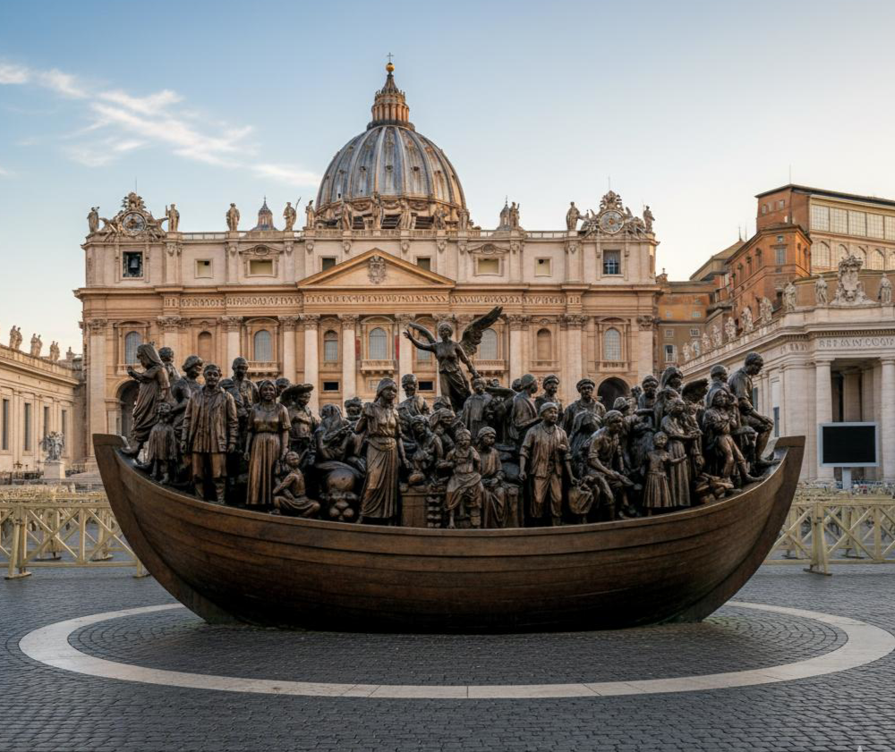
‘Angels Unawares’
A bronze sculpture in St. Peter’s Square, Vatican City
by Canadian artist Timothy Schmalz, installed in 2019

